What the Flying Yoda can teach charities

There’s been a lot of excitement this week about the new Star Wars film. But this blog’s not about that, although it is about Yoda. Yoda and charities.
OK, let me explain.
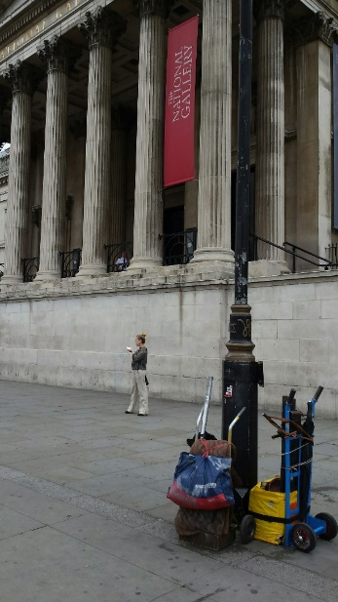
I want you to walk with me around London’s Trafalgar Square, let’s say at around 10 on a weekday morning. What do you see? A bit of a crowd of tourists about to head into the National Gallery maybe? Some others taking selfies by the fountains? Maybe an artist has begun a chalk drawing on the pavement?
Sure, but there’s something you may have missed. It’s in this picture. The foreground, not the background. Easy to look straight past, eh?
But these trollies contain the gear that keeps Yoda flying in the air. If you hang around, you can watch them gradually building the structure. Eventually he looks a little like this:
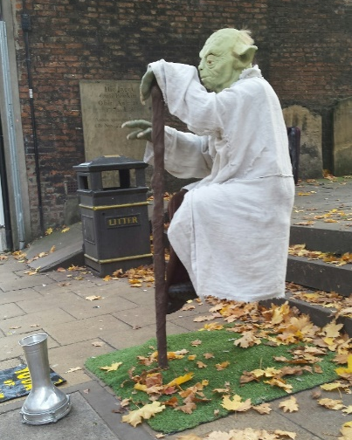
Flying Yoda is pretty impressive, and there’s a few of them around now. In fact I took this picture of him in York.
But why am I writing about flying Yoda in this blog about charities? Well… a few things to teach us Flying Yoda has.
Let’s be clear about what keeps us flying
Like this Yoda, all charities need a support structure to make it look like we’re flying. But I wonder whether we’re not selling the general public a line that we’re ‘all about the flying.’
And this does a disservice to ourselves and to our sector.
The unseen also has great value
We need to be clear why the staff costs we pay are so important, not just in providing our services but in keeping the show on the road in so many different ways. Similarly, I worry that we are often in danger of undercharging for, and consequently undervaluing, so much of what we do.
We are not circus acts
And this is the most important point. Do you think anybody in Trafalgar Square actually thinks they're witnessing magic? Isn't part of the fascination in wondering how it's done? We, as charities, need to shatter the often held perception that should be able to perform our miracles for free. We need to explain why we’re the right people to do the job.
We need to be clear both about the benefits of what we do, and the expertise we bring to finding the solutions.
We are professionals. What we are doing is so important. Let’s stop hiding it beneath a long cloak.
May the force be with you.

